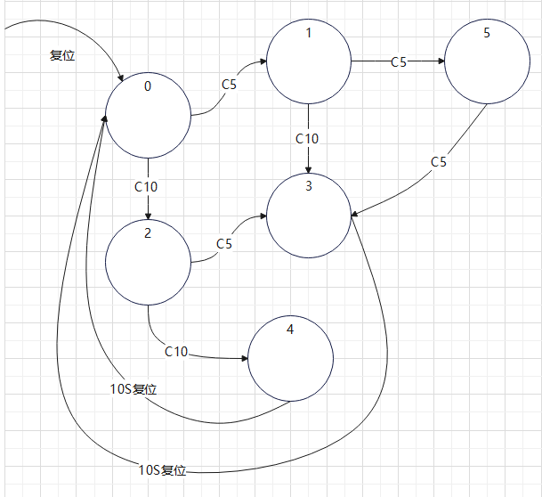

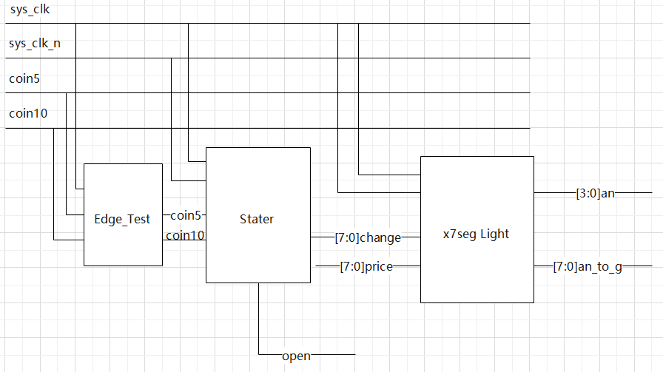

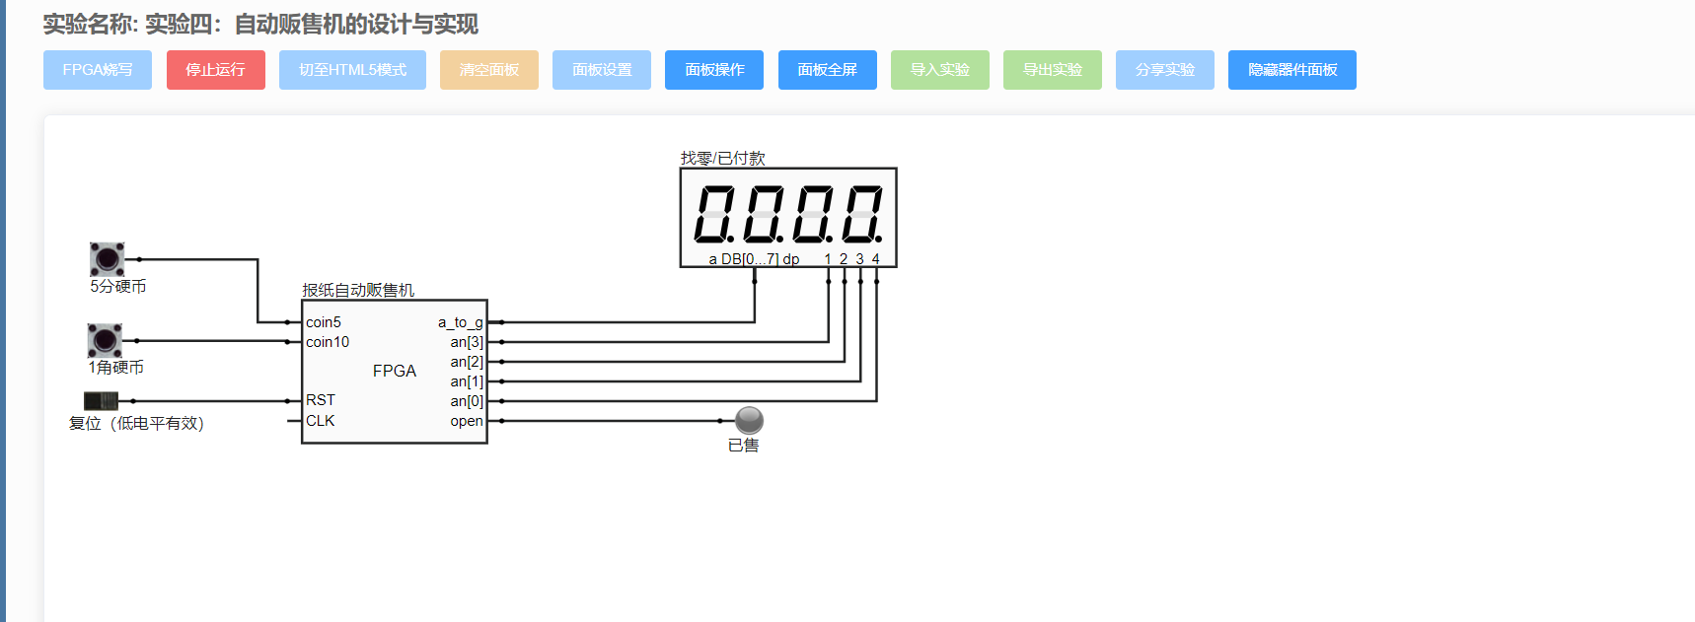

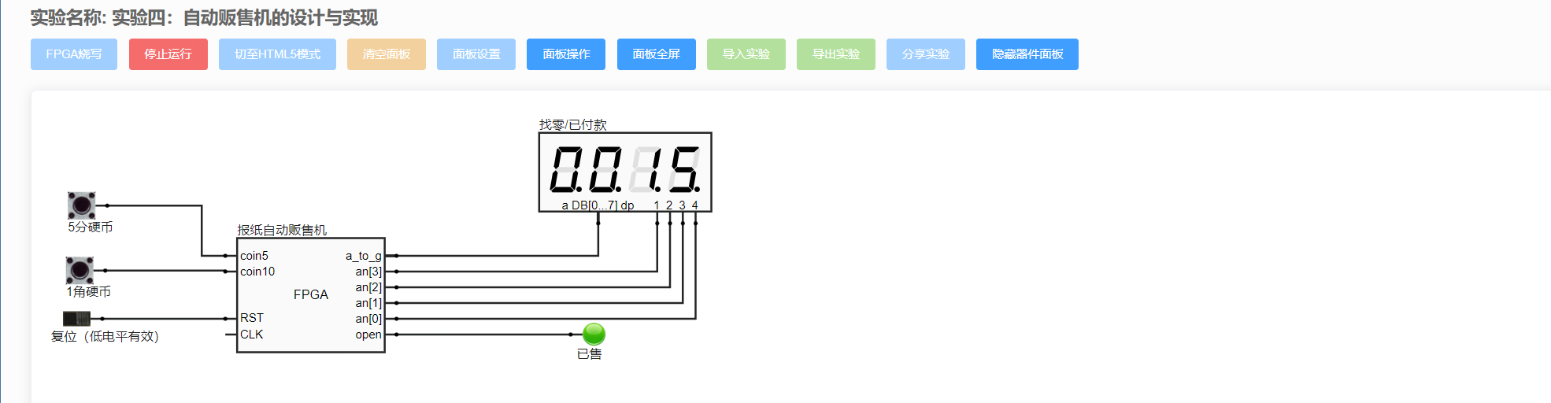

paddlepaddle 1.5.2 requires graphviz, which is not installed.

paddlepaddle 1.5.2 requires prettytable, which is not installed.

paddlepaddle 1.5.2 requires rarfile, which is not installed.

paddlepaddle 1.5.2 requires recordio>=0.1.0, which is not installed.

paddlepaddle 1.5.2 requires matplotlib<=2.2.4, but you have matplotlib 3.5.1 which is incompatible.

paddlepaddle 1.5.2 requires nltk<=3.4,>=3.2.2, but you have nltk 3.7 which is incompatible.

paddlepaddle 1.5.2 requires scipy<=1.2.1,>=0.19.0, but you have scipy 1.8.0 which is incompatible.